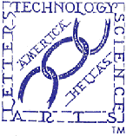 | THE HELLENIC LINK, Inc.  ΕΛΛΗΝΙΚΟΣ ΣΥΝΔΕΣΜΟΣ  Member Update- BULLETIN  Editorial Committee: Ahilleas Adamantiades, Evangelia Georgoulea,  Maria-Eleftheria Giatrakou, Dean C. Lomis, Katherine Efthymiatou-Stabile  Contributing Editor: Dimitrios Oreopoulos Acting Editor: Constantine Efthymiou  No. 75, January 2009

Reflections on Being Youthful at the Start of Yet Another Year*
(Personal Options, as related by a student)

“On the first day of school, our professor introduced himself, and challenged us to get to know someone we didn’t already know. I stood up to look, when a gentle hand touched my shoulder. I turned around to find a wrinkled, little old lady beaming up at me with a smile that lit up her entire being.
She said, “Hi, handsome. My name is Rose. I am eighty-seven years old. Can I give you a hug?”
I laughed and enthusiastically responded, “Of course you may!” and she gave me a giant squeeze.
“Why are you in college at such a young, innocent age?” I asked.
She jokingly replied, “I am here to meet a rich husband, get married, and have a
couple of kids…”
“No, seriously,” I asked. I was curious what may have motivated her to be taking on this challenge at her age.
“I always dreamed of having a college education and now I’ m getting one” she told me.
After class, we walked to the student union building and shared a chocolate milkshake.
We became instant friends. Every day for the next three months we would leave class
together and talk nonstop. I was always mesmerized listening to this “time machine” as she shared her wisdom and experience with me.
Over the course of the year, Rose became a campus icon, and she easily made friends wherever she went.
She loved to dress up, and she reveled in the attention bestowed upon her from the other students. She was living it up.
At the end of the semester, we invited Rose to speak at our football banquet. I’ll never forget what she taught us. She was introduced, and stepped up to the podium. As she began to deliver her prepared speech, she dropped her three by five cards on the floor. Frustrated and a little embarrassed, she leaned into the microphone and simply said, “I’m sorry I’m so jittery. I gave up beer for Lent, and this whiskey is killing me! I’ll never get my speech in order, so let me just tell you what I know.”
As we laughed, she cleared her throat and began, “We do not stop playing because we are old; we grow old because we stop playing!” There are only four secrets to staying young, being happy and achieving success. You have to laugh, and find humor every day. You’ve got to have a dream. When you lose your dreams, you die.
“We have so many people walking around who are dead. And don’t even know it!”
“There is a huge difference between growing older and growing up”
“If you are nineteen years old, and lie in bed for one full year, and don’t do one productive thing, you will turn twenty years old. If I am eighty-seven years old and stay in bed for a year and never do anything, I will turn eighty-eight. Any body can grow older. That doesn’t take any talent or ability. The idea is to grow up by always finding opportunity in change. Have no regrets.”
“The elderly usually don’t have regrets for what we did, but rather for things we did not do. The only people who fear death are those with regrets.”
She concluded her speech by courageously singing the “Rose.” She challenged each of us to study the lyrics and live them out in our daily lives.

At the year’s end, Rose finished the college degree she had begun all those years ago.
One week after graduation, Rose died, peacefully, in her sleep.
Over two thousand college students attended her funeral in tribute to the wonderful woman, who taught by example that it’s never too late to be all you can possibly be.
When you finish reading this, please send this peaceful word of advice to your friends and family, they’ll really enjoy it!
These words have been passed along in loving memory of ROSE:

- REMEMBER, GROWING OLDER IS MANDATORY, GROWING UP IS OPTIONAL.
- We make a Living by what we get; we make a Life by what we give.
- God promises a safe landing, not a calm passage. If God brings you to it, He will bring you through it.
- “Good friends are like stars….You don’t always see them, but you know they are always there.”

------------------------------
* Essay contributed by HL member Christina Vayas, Professor of Social Work, Athens, Greece
E-mail address: vayas@ath.forthnet.gr

A Glimpse on Hellenic Education at Present

There are some remarkable happenings in the world of Hellenic Education at this time.

In the mother-country of Hellenic Education Greece, in which the course of educational matters inevitably affects the fortunes of all Greeks, including those living abroad, the dawn of 2009 -- not withstanding the continued for years educational turmoil and even vehemence -- brings at last a chance for renewal and normalization. The Government of Greece took a step to face squarely the educational dilemma. The Prime Minister, Mr. Kostas Karamanlis has sent to the Greek Parliament a proposal for a priority - i.e., before the Agenda - discussion and formation of an across political parties consensus-design of the future course of the National Paideia. Integral characteristics of the proposal are a high degree of urgency and a political judgment that a long range and viable settlement of educational imperatives for all levels of schooling in Greece and particularly for tertiary education can originate only from a smooth integration of the divergent political positions manifest in the Parliament.

That a solution can be reached by serious and responsible political leaders, motivated by the good of their country, would be deemed reasonable and feasible -- a priori. That this may turn out to be a wish only under the present circumstances, unfortunately, it is quite conceivable.
The major problem is, as always, the innate traits of selfish individualism inherent in the Greek character, which keeps the Greeks away from reaching a consensus on practically anything. Historically, the saving grace from this negative attitude has been that when the nation faces extraordinary threatening situations, the self destruct negativism temporarily subsides in favor of a reconciled unanimity in action. Certainly, it takes superior personalities to intervene and to act in this spirit and manner, demanded each time by critical circumstances. Let us remember Themistocles who, just before the naval battle of Salamis, facing a degrading humiliation at the most critical war council by one of the Greek military chiefs on what to do with the Persian invaders, the dissenting Corinthian admiral Adeimantos, who in support of his argument gave Themistocles a resounding smack in the face. Can we imagine what the outcome of that historic battle could have been if Themistocles had taken the humiliation “to heart” and reacted in kind? Fortunately for Hellas (and Europe), he possessed wise acumen and uttered instead with astonishing equanimity these celebrated words to Adeimantos: “Πάταξον μέν, άκουσον δέ!”
Can we expect a similar demeanor among the Greek legislators during the forthcoming discussion of the “Education Issue” in the Greek Parliament? “Yes, we can!” All Greek politicians are proclaiming that the country is in a crisis at this juncture. Accordingly, their Greek countrymen are more than justified to expect their elected representatives to sacrifice micro political ambitions on the altar of national salvation, as the stakes rise too high. To not do so, it would spell national regression with incalculable ramifications. Let us hear, then, responsible voices of reason, prudence and conciliation, and have resolutions as well in that spirit, at least on the burning issue of education. As a result, after the exasperating low point at present, hopes about a better future could soar high, again!

Closer to home, here in America, there are also fresh developments in the realm of Hellenic Education, which allow optimism for the educational future of our young. There has been a moderate but significant progress made in the sector of Parochial Greek Education. After a long stretch of plummeting enrollments and school closures, new schools are opening and qualitative improvements of instruction are being introduced in both Day and Afternoon Schools across the Country.
For example, according to press reports, the thriving Greek – American community of Baltimore, Maryland- several parishes strong- gained at last access to Hellenic primary education by establishing a focal School in the Community of St. Demetrios. This first Greek Orthodox Day- School was created initially in 2000 by the individual efforts of Mrs. DemeAnn Lomis as pre-kindergarten-kindergarten, and was recently graduated to primary by addition of one class annually. The School was substantially established by the persistent exertions of the Community and of its Pastor, the Rev. Elias Constantopoulos, as well as by the constant encouragement and support of the Metropolitan Evangelos of the New Jersey Diocese. Recently, the Metropolitan expressed publicly his great satisfaction for the opening of this first Day-School in the area of His ecclesiastical jurisdiction, and promised that it will not be the last one. It is remarkable, that this School is fiscally independent from the budget of the Community not burdening it, providing rather a new source of economic strength to the Community. Similar creative activities in support of Hellenic Education have been undertaken and increasingly reported by other Archdiocesan Districts, such as the Metropolis of New England and of California. If we can ascertain details, we will be happy to return to the subject with additional informative report.

Within the next few days (January 15-17, 2009), a significant educational event concerning Hellenic Education will take place in Miami, Florida. In a two-day Conference, the Committee on Education of the World Council of Hellenes Abroad (SAE), in cooperation with the General Assembly of the Federation of Hellene-American Educators, will focus on the theme “Charter Schools: Accomplishments, Findings, & Perspectives after Nine Years of Operation.” The Conference will include a visit of the Charter School
“Archimedean Academy,” by many considered a model among the Charter Schools having a Greek cultural orientation. According to the Public Announcement, the goal of the Conference will be to review the course of the charter schools of Greek interest and also the prospects for expansion and for qualitative improvement. As is known, such schools offer the option of general education as well as learning of the Greek language and related subjects with favorable economic terms, being especially useful in areas where there are no school programs of Greek communities.
Even though we are not privy to a detailed program of presentations and discussions, it is obvious that the focal themes of the Conference are of great interest and importance. If the conclusions to be reached will be followed by well pondered decisions and a sound action plan, this Conference might very well signify a historic development.

The Hellenic Link, Inc. NGO, by means of its members who are on faculties of American, Canadian, or Greek universities as educators of the broad or narrow connotation of the word, has been making significant contributions of its own recently for the advancement of Hellenic Education, particularly in North America. Even though substantially unrecognized as such, concerted action under its auspices signals a substantive role, which we would be grossly remiss if we did not mention. Thus, after a careful analysis of the possible approaches for the advancement of Hellenic Education (A Hellenic Education Plan for America, NY 2005), HL proceeded to define and induce critically needed educational programs, which were out of the planning horizon of others concerned with Hellenic Education ex officio: the Advisory Council on Hellenic Education of the HL started an effort to generate interest in the American academic community to consider and initiate core programs of indigenous education for teachers of the Greek language and culture. As the readers of the Bulletin know, in 2008 a collaborative Colloquium was held to consider the premises for such a program with the faculty of one American academic institution, The Richard Stockton College of New Jersey . The Colloquium was successful in its findings, as it was followed by a collaborative interaction with Hellenic institutions and academics for a joint program so structured to utilize modern informational technology, that is distance teaching/learning for the academic objective highlighted above.. We are in the pleasant position to report that a second institution of higher learning, the Concordia University in Montreal Canada, is now showing active interest in considering a similar program, as reported below

The pointed educational developments, taken together, undoubtedly constitute progress that will encourage
subsequent efforts for further accomplishments. However, one should not miss an unmistakable lack of coordination, which questions effectiveness for the long term in the highly competitive and complex environment of American multiculturalism. Without belaboring the point, let us state that as in the case of the political challenge faced by the Greek Parliamentarians in the present impasse on education, the principal actors of Hellenic Education on the American scene, should also try to build a durable educational system using the approach of consensus and commonality of cultural interests in close reference to the requirements of the society in which we live.
CJE
Canadian University Supports a Proposed Indigenous Education for Greek Language Teachers
The Hellenic Studies Unit of Concordia University, soon after the establishment and inauguration in the Fall semester of 2008 of a Minor in Hellenic Studies rich in course offerings, is planning to upgrade further the level of its programs by creating favorable conditions for a program aimed at educating future teachers of the Greek language and culture. Planned public Lectures on the subject in 2009 are indicative of the serious methodical approach adopted in pursuit of this highly demanding but crucial for the Hellenic community academic objective.
Coordinator of the Hellenic Studies Unit and determined Pioneer of the new academic program is Dr. Nikos Metallinos, Professor of Communication Studies. Dr. Metallinos is a Member of the Advisory Council on Hellenic Education of the Hellenic Link, Inc.
We are happy to disseminate information on the planned series of 2009 Lectures, which the HL co-sponsors fervently:
ANNOUNCEMENT
Τhe Hellenic Studies Unit (HSU) of Concordia University, in collaboration with the Faculty of Education of McGill U., The International Society of the Friends of Nikos Kazantzakis (I.S.F.N.K) and the Hellenic Community of Montreal (H.C.M), has scheduled the following Lectures for the academic year 2008-2009:

1. January 30, 2009 (See full Announcement in this Bulletin)
Topic: Internet Programs for Teaching Greek Abroad
Speaker: Dr. Andre Gerolymatos, Simon Fraser University

2. March 6, 2009
Topic: Educating the Future Ethnic Community Teachers
Speaker: Dr. S R. Steinberg, McGill University

3. May 7, 2009
Topic: Education Curriculum for Teachers of the Greek Language
Speaker: Dr. Harriet Petrakos, Concordia University (Education)
, .
All Lectures will be given at Concordia University, Hall Building, and Room 767
Address of HSU: Department of Communication Studies, 7141 Sherbrooke Street West, Montreal, QC, Canada Director: Nikos Metallinos, Tel. 514.848.2424 ext. 2536, Fax: 514.848.4257; e-mail: nikos.metallinos@concordia.ca Website: http://www.concordia.ca/hellenicstudies

ANNOUNCEMENT-INVITATION
The Members and Friends of the Hellenic Link, Inc. are cordially invited to attend the following academic event of great interest and significance for the nurture of the Greek language in North America, presented by the Hellenic Studies Unit, Faculty of Arts and Science, Concordia University, Montreal, Canada:

2009 hellenic Studies Lecture series
At: Concordia University, Hall Building, Room 767
7141 Sherbrooke Street West, Montreal, QC
When: Friday, January 30, 2009 at 7:00 P.M.
Website: http://www.concordia.ca/hellenicstudies

GUEST SPEAKER*
dr. Andre Gerolymatos
Director, Hellenic Studies Program
Simon Fraser U.,Vancouver, BC
LECTURE TOPIC
“Internet Programs for the Teaching of the Greek Language and Culture”
(«Διαδικτυακά Προγράμματα Διδασκαλίας της Ελληνικής Γλώσσας και Πολιτισμού στο Εξωτερικό»)

Introductions to the Lecture by :Dr. Nikos Metallinos,Director of the HSU; Prof. Joanne Locke, Dean, Arts & Sciences, Mrs. Maria Karnoutsou, Consul General of Greece in Montreal, Mr. Dimitrius Manolakos, President, Hellenic Canadian Congress.
*Andre Gerolymatos was educated in classics and modern history at McGill University in Montreal. He specializes in Military and Diplomatic History, and has published a long list of articles and several books in these fields. From 1987-1996, he directed the Hellenic Studies Center at Dawson College in Montreal, in 1996, he received the Hellenic Canadian Congress of BC Chair in Hellenic Studies at Simon Fraser University, where in 1997, he was appointed Director of the Research Institute on Southeastern Europe.
The Lecture-Event includes the award of the Annual Arnopoulos
Scholarship, which will be followed by a Reception.
Contact Telephone for information:
( 514) 848-2424 Ext.2536

Art and Social Order in Classical Athens
We wish to warmly recommend a visit to the current Exhibition at the Onassis Cultural Center, Olympic Tower and 645 Fifth Avenue (with entrances on both 51st and 52nd Streets). The Exhibition on the Theme “Worshipping Women: Ritual and Reality in Classical Athens” sheds light on a little cognizable aspect of the Ancient Hellenic Civilization, the status of women in the Athenian City-State. This highly educational Exhibition, presented by the Cultural Center in collaboration with the Hellenic Ministry of Culture and the National Archaeological Museum of Athens, is open to public with free admission daily Monday-Saturday, 10:00 A.M. – 6:00 P.M. Complimentary guided tours for groups of visitors are conducted every Tuesday and Thursday at 1:00 P.M. For more information about the guided tour program, interested parties should contact the Cultural Events Department at the telephone number: 212.486.4448. It is noted that the Exhibition will remain open until May 9, 2009.

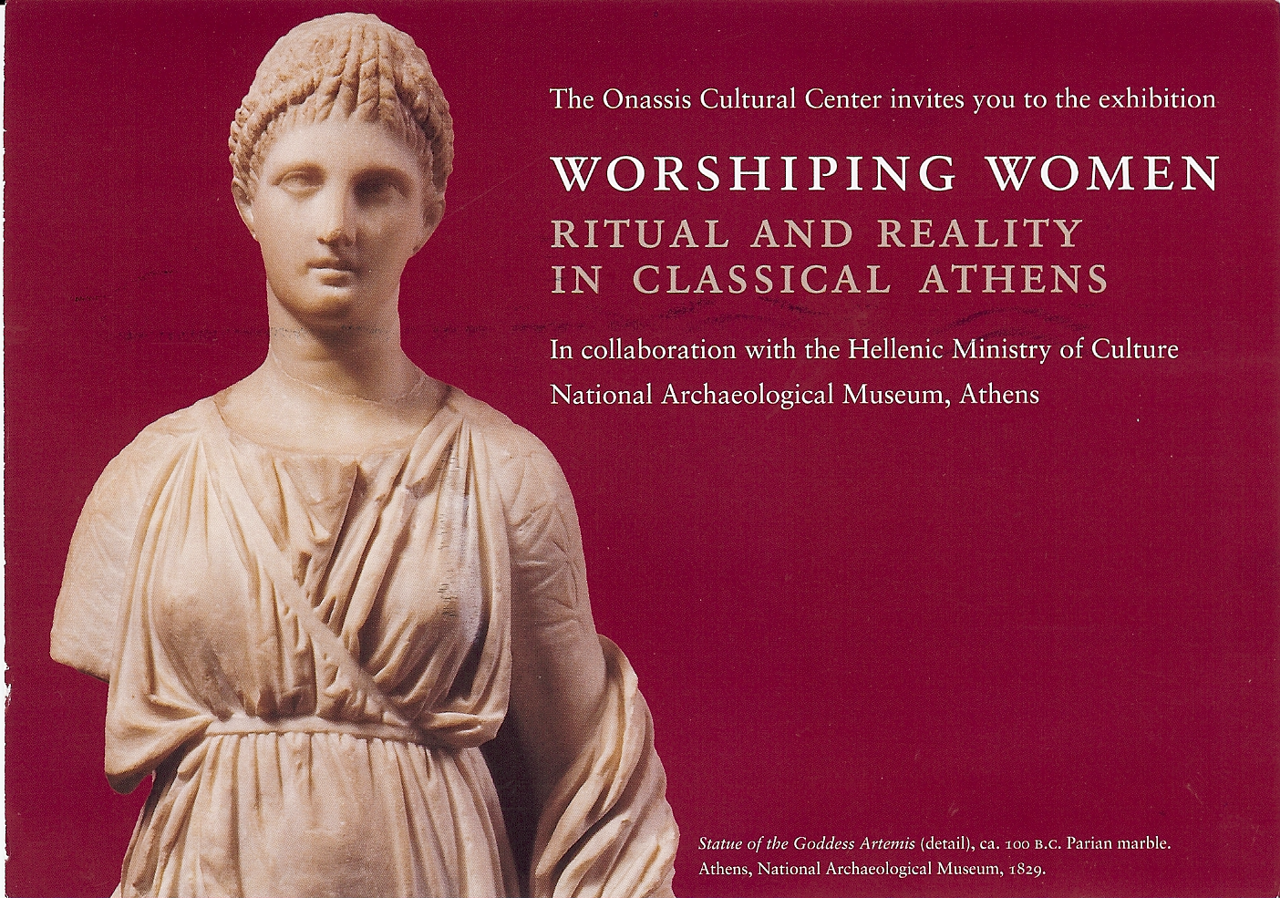

Career Fair Announcement-Invitation
Our members and readers are kindly requested to bring to the attention of interested
friends and acquaintances that the Cyprus U.S. Chamber of Commerce in cooperation with several Hellenic Organizations sponsors an Annual Career Fair 2009:

Where: The Holy Trinity Cathedral Center Ball room, 337 East 74th Street,
Between 1st and 2nd Avenues, Manhattan, New York

When: THURSDAY, JANUARY 29, 20009—4:00pm-7:00pm

Admission is Free
Refreshments will be served

There will be a Presentation on Effective Resume Writing/Interview Techniques
By Ms. Maggie Stavrianides,

Job –seekers should come prepared with resumes, as Company
representatives will be available to discuss career opportunities

Companies participating are from the following industries: Banking, Law Firms, Accounting, Architects,
Engineering, Contracting, Importers, Financial Advisors, Computers, Real Estate, Investment Banking,
Cosmetics, Social Work and Others

For Further Information contact:
Despina Axiotakis, Executive Director at 201-444-5609 or e-mail at cyprususchamber@aol.com

Professionals in every discipline or field of endeavor, whether of Greek Descent or Philhellenes, are cordially invited to join the Hellenic Link, Inc. as members. It is quite easy and useful! Just contact us at any of the following addresses.

THE HELLENIC LINK, Inc.

A NON PROFIT CULTURAL AND SCIENTIFIC ASSOCIATION

OF HELLENES AND PHILHELLENES

INCORPORATED IN DELAWARE

Suite No. 278, 38-11 Ditmars Blvd, Astoria, New York 11105
Web Site: http://www.helleniclink.org Email: info@helleniclink.org

Contact Telephone : (718) 217- 4285

